**2017 EST Revision Document**

**Yr 12 Essentials Mathematics**

**Baldivis Secondary College**

**Basic Information**

The EST is under standard test conditions.

Duration = 50 min

EST Date = Wednesday 24th May (Week 5)

Additional Items

* **A calculator of the type used in school-based assessments for this course (basic scientific preferred but not necessary)**
* **One A4 doubled-sided page of notes**

**Content that the EST is based upon.**

**Cartesian plane**

3.3.1  demonstrate familiarity with Cartesian co‐ordinates in two dimensions by plotting points on the Cartesian plane

3.3.2  generate tables of values for linear functions drawn from practical contexts

3.3.3  graph linear functions drawn from practical contexts with pencil and paper and with graphing software

**Using graphs**

3.3.4  interpret and use graphs in practical situations, including travel graphs, time series and conversion graphs

3.3.5  draw graphs from given data to represent practical situations

3.3.7  identify the rate of change of the dependent variable, relating it to the difference pattern in a table and the slope of an associated line drawn from practical contexts

3.3.8  determine and describe the significance of the vertical intercept in practical situations

3.3.9  use the rate of change and the initial value to determine the linear relationship in practical situations

3.3.10  interpret the point of intersection and other important features of given graphs of two linear functions drawn from practical contexts; for example*,* the ‘break‐even’ point

**Bivariate scatterplots**

3.4.12  describe the patterns and features of bivariate data

3.4.13  describe the association between two numerical variables in terms of direction (positive/negative), form (linear/non‐linear) and strength(strong/moderate/weak)

**Trend line**

3.4.15  fit a trend line by eye

3.4.17  use the trend line to make predictions, both by interpolation and extrapolation

3.4.18  recognise the dangers of extrapolation

3.4.19  distinguish between causality and association through examples

**PRACTICE PAPER**

Marks: 33 marks Time: 50 min

The immunization rates in Australia have been recently in the news highlighting the strong divide within the community between the health department and parent groups. There is enormous debate about both the effectiveness and safety of the various vaccines available within Australia. The disease mumps was one of the first to have a vaccine widely available to babies (MMR).

The table below has information from the Health Department website.

|  |  |  |
| --- | --- | --- |
| Year | Percentage of children fully vaccinated  (12month-15 month) | Number of notifications per 100,000 population of Mumps infection.  (0-4 year olds) |
| 1999 | 86.15 | 2.6 |
| 2000 | 89.23 | 1.8 |
| 2001 | 91.08 | 1.2 |
| 2002 | 90.09 | 0.8 |
| 2003 | 91.32 | 0.9 |
| 2004 | 91.11 | 0.8 |
| 2005 | 90.93 | 0.7 |
| 2006 | 90.73 | 0.7 |
| 2007 | 91.24 | 1.0 |

1. [4 marks]

Use the grid below to plot a scatter graph of the above data.

2. [3 marks]

Describe the association between the immunization rate and number of notification of the mumps.

3. [2 marks]

On the graph above draw a line of best fit

4. [3 marks]

Use your line of best fit to predict the number of reported cases of Mumps if children 12-15 months old in Australia have an immunization percentage of 94%. Comment on your prediction.

5. [3 marks]

A lobby group in 2008 claimed that;

“The bacteria that causes Mumps has been almost eliminated due to the vaccination program over the past 10 years”

Would this data support this claim? Justify your response.

The table shows the linear relationship between the length of a mobile phone call and the cost of the call.

BEBO INTERNATIONAL MOBILE PHONE PLAN

|  |  |  |  |
| --- | --- | --- | --- |
| **Length of call (minutes)** | **1** | **2** | **3** |
| **Cost (dollars)** | **7.6** | **14.4** | **21.2** |

6. [2 marks]

Draw the graph of the mobile phone plan on the axis provided.

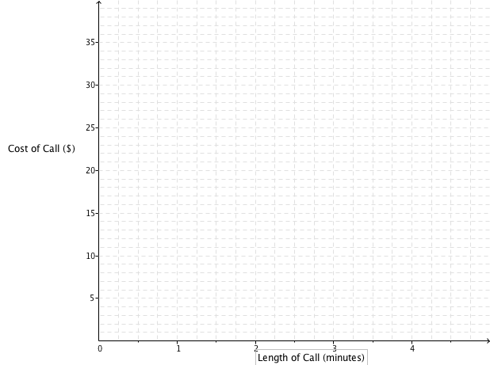

7. [1 marks]

What is the cost of a 4-minute phone call on this BEBO mobile phone plan?

8. [2 marks]

What is the cost per minute for the BEBO phone calls?

9. [3 marks]

What is the rule to calculate the cost (c) of a phone call of “m” minutes on the BEBO mobile phone plan?

10. [3 marks]

GINTS international mobile phone plan uses the formula c=3.4m+11. Draw this on the graph above.

11. [2 marks]

Which mobile plan is better if I plan to make a phone call of 1 ½ minutes. How much better would it be?

12. [2 marks]

What length of call are the two plans the same cost? What is the cost at this time?

13 [3 marks]

A third phone company wishes to enter the market as the cheapest phone plan for the first hour. They are not charging a line rental fee. What would be the maximum rate they could charge to be able to make this claim?

**SKILLS PRACTISE**